**PROJECT REPORT ON**

**“FACT NOTIFIER APPLICATION”**

**Submitted By:**

**Harsh Rathi, Roll: 11812092, CS 2**

**Narendra Pal, Roll: 11812018, CS 1**

**Submitted To:**

**Mr. Anoop Patel**

**Department of Computer Engineering**



**INDEX**

1. **ABSTRACT IDEA**
2. **TOOLS**
3. **SPECIFICATION AND DESIGN**
4. **IMPLEMENTATION**
5. **RESULT AND EVALUATION**
6. **BIBILOGRAPHY**

**ABSTRACT IDEA**

The kowledge has become the very important and necessary component for us in todays world which makes us stand out different from others. The people have become so busy with there work that they don’t have time to acquire knowledge on their other interest and soon they lost interest in them.

The idea of the project is to create an application which enhance the user knowledge by showing the interesting facts based on the users interest after the certain time interval decided by the user. The idea of the project is also to show the facts in the form of windows notification without interrupting the user from it activities on the computer machine.

**TOOLS**

Tools used to run this project are following:

>>.Programming language used: Python 3.7.4

>>. Module required to run this project:

* Tkinter
* time
* PIL
* Random
* win10toast

Tkinter: This module is used to design the GUI(Graphical User Interface) for the application. With the GUI it is easier for user to carry out the functionalities he want.

Time: This module is used to show the facts notification on windows after some interval of time decided by the user.

PIL: This module is an Imaging library in python and this is used to make the grphical interface more attractive.

Random: This module is used so that the user does not get notification continuosly based on his only one interests out of many but instead to get the notification in random order of their interests.

Win10toast: This module is used to send notification on users system.

A file handling is also used to manage the interests of the user and the interest provided by the application.

**SPECIFICATION & DESIGN**

When the users first runs the program, a new window with title “Welcome to the fact notifier” appears in form of graphical user interface which prompts the user to select his or her interests and the time interval after which he wants to receive fact notifications. Its look like this:

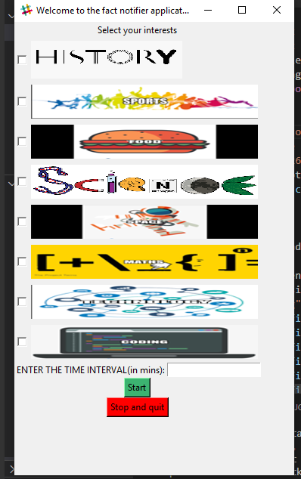

When the user selects his/her interests and choose the time interval and press the button “Start” a new window titled as “Interests” appears which shows the interests of users and time interval selected and further ask the user to confirm his selection and start receiving the notifications. The new windows looks like this:

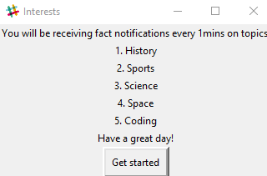

On the moment user presses the “Get started” button, the applications start to show facts in random order of the users interests after every time interval which is selected by the user.

The notification looks like this:

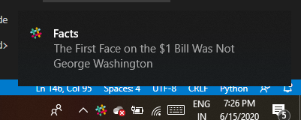

Also when the user clicks the “Get started” button some changes occurs on the window in which the user was asked to select his interests which looks like this:

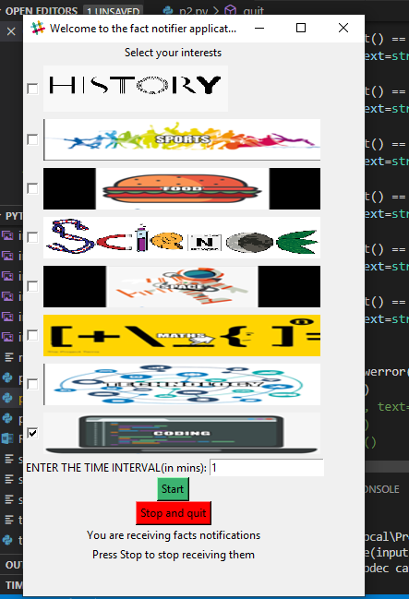

Its tells the user that he can stop receiving the notifications by pressing the “Stop and quit” button. And on the moment user presses the button a new info box appears which show iformation that “You will not receive any notifications and the applications get closed.

It looks like:

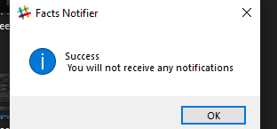

This was the normal working of the application when the user makes the valid selection.

But it is possible that user sometimes do not makes the valid selection. In case of this application they are following:

* If the user does not select any interest and only enters the time interval, then a error message box appears which tells the user to select his interest. It looks like:

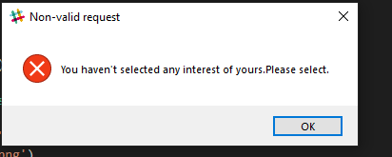

* And non valid request possible is that user may not enter the time interval or he may not enters the valid time interval e.g a mins. In this case, an error message box appears which tells the user to enter the valid time interval. It looks like this:

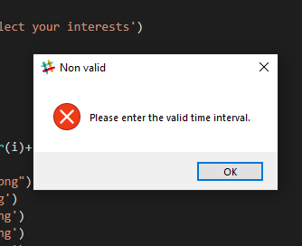

**Understanding the working of Application**

**(Implementation)**

A GUI is deigned which prompt the user to select his interests and select the time interval.

In case the user makes the non valid request, the error is shown to the user about his non valid selection.

If the user makes the valid selection, then the interests of user is stored and the time interval after which he want to receive notification is also stored.

There is file for every interest shown by the GUI which have the fact based on that interest stored in them.

When the user selects his interests, all the data from the interest files are retrived and stored in a single file called factfile. The lines in this file is then shuffled and retrived one by one and shown as notification to the user.

**RESULT AND EVALUATION**

* The notification is produced on user machine after the time interval (selected by the user) which shows the fact about the interests selected by the user.
* This application can be used as a tool to ehance the user knowledge in the field of user interests without hindering the user workspace or working style.

**BIBILOGRAPHY**

<https://www.geeksforgeeks.org/python-gui-tkinter/>

<https://www.geeksforgeeks.org/windows-10-toast-notifications-with-python/>

<https://www.geeksforgeeks.org/working-images-python/>

<https://www.google.com/webhp?hl=en&sa=X&ved=0ahUKEwj4jc33lITqAhV8xTgGHXmJBX8QPAgH>

<https://pixabay.com/>